**About the data**

Konga retail store data of customers’ transactions for the year 2023 and Q1 2024

* 302, 011 records

Customer key terms

* Regular – Customers who signed up for regular membership
* Premium – Customers who signed up for premium membership
* New – New customers acquired on the platform

Transaction

* Total purchases – total amount spent
* Total transactions – total transactions carried out by customers

Rating

* 5 – Excellent Quality
* 4- Very Good Quality
* 3 -Good Quality
* 2- Fair Quality
* Poor Quality

**Business Questions:**

* What are the 2 best-selling product categories?
* What drives the revenue?
* What do our best customers look like?

**North Star Metrics**

* Revenue by product category
* Key indicators of revenue growth
* Customer segmentation profile

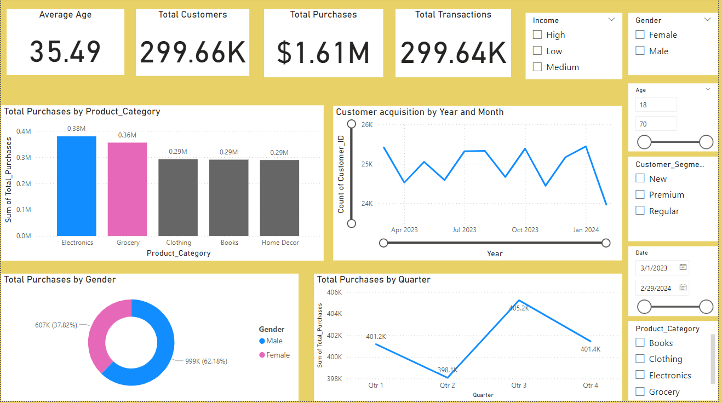

**Observations:**

* The total number of customers is 299k (64K Premium, 145k Regular, New 90k)
* The total purchase amount made for the time is $1.61M
* Total transactions amount carried out for that period is 299.64k
* The lowest revenue made was in Q2 and highest in Q3
* Gender split of customers is 62% male and 38% female
* The average number of customers acquired month by month is 24,900. An 8.4% customer acquisition rate for the period.

Insights:

**Product Category:**

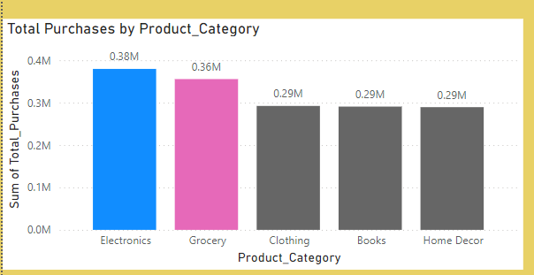

* The two best-selling product categories are Electronics and Grocery, and this fact cuts across the three customer segments (Regular, Premium and New). These two categories also have the highest number of transactions made. However, even though these two have a high purchase amount, we can see that there has been a steady decline and a downward trend in the number of customers interested in these products overtime. 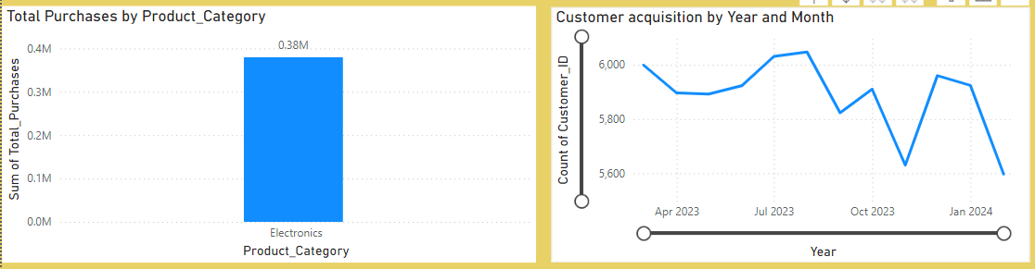This is particularly true for Electronics as the downward trend in customers have also led to a downward trend in revenue.

**Rating:**

* Rating drives the revenue for this store – 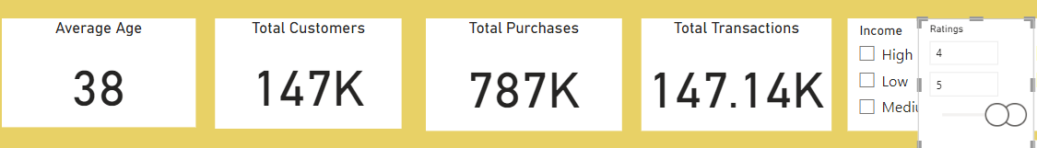The data shows that a lot **more customers are willing to spend more on products with a 4-5 rating** than a 1-2 rating. This **tells us that the quality of our products matters a lot in describing our customers’ purchase behavior** and an important revenue driver.

**Best Customer Profile :**

* 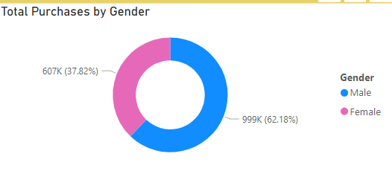From the gender split our male customers represent 62% of the total transactions while females represent 38%

Also, taking the customer age subset (18-30), (31-50), (51-70), it’s evident that males (18-30) made a total purchase of (496k), the highest of the three age subsets, with the average best performing age subset of 23.

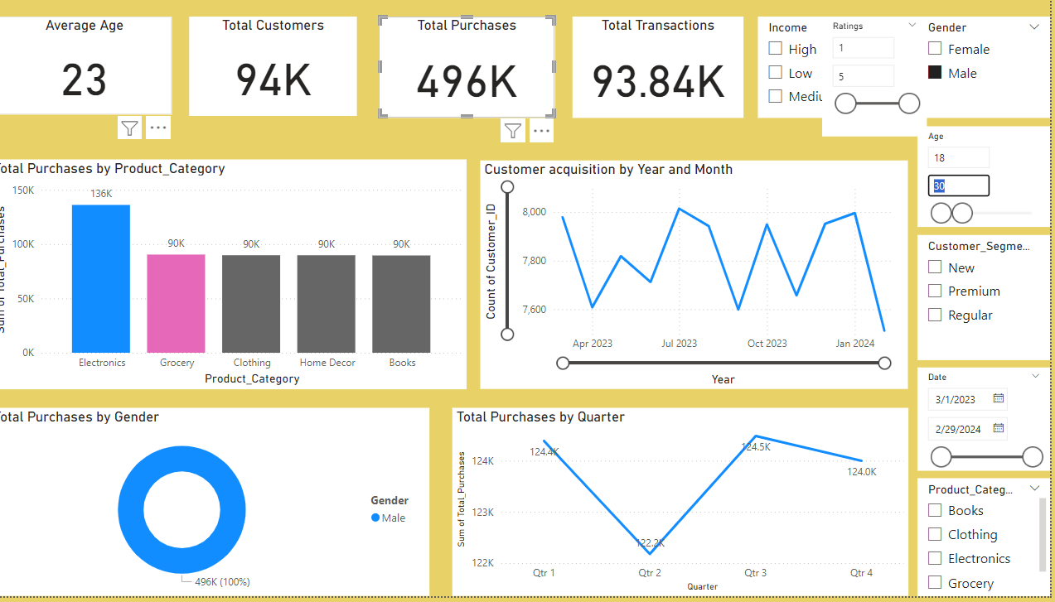

For females, the trend is the same, female customers (18-30) made a total purchase of 273k and 22 being average age. So, we can infer that **our best customer profile** would be overall **Male between the ages of 18-30.**

**Recommendations:**

**Marketing:**

* Marketing should target more customers who are male and between the ages of 18-30 through targeted campaigns and promotional events as they are the most valuable in terms of driving revenue for the business.

**Sales:**

* Sales need to find innovative pitches and strategies to retain and recapture customers’ interests in our two best-selling product categories (especially Electronics) that has had a downward trend in the number of customers interested but still provides the highest margins in terms of revenue for the business.

**Products:**

* Product needs to ensure that the quality of the product categories is between 4-5 (Excellent) as the data suggests this brings the highest profitability and customers are willing to spend more on quality products.
* Product needs to find low-margin areas e.g. Cut costs of underperforming product categories like Clothing, Books and Home décor to increase profit.